**HO CHI MINH CITY UNIVERSITY OF TECHNOLOGY AND EDUCATION**

**FACULTY FOR HIGH QUALITY TRAINING**



**PROJECTS OF MACHINE DESIGN**

**Exercises for processing image data by using CNN**

**LE HOANG HOA 19146122**

**Teacher: NGUYEN TRUONG THINH**

**Ho Chi Minh City, 22th of May 2022**

**Bài 1: Cifa100**

import cv2

import os

import numpy as np

import matplotlib.pyplot as plt

from tensorflow.keras.utils import to_categorical

from sklearn.model_selection import train_test_split

from sklearn.preprocessing import OneHotEncoder

from keras.models import Sequential

from keras.layers import Dense,Activation,Dropout

from keras.preprocessing.image import load_img

from keras.datasets import cifar100

(X_train,Y_train),(X_test,Y_test) = cifar100.load_data()

Downloading data from <https://www.cs.toronto.edu/~kriz/cifar-100-python.tar.gz>

169009152/169001437 [==============================] - 4s 0us/step

169017344/169001437 [==============================] - 4s 0us/step

X_train.shape

(50000, 32, 32, 3)

labels = ['apple', 'aquarium_fish', 'baby', 'bear', 'beaver', 'bed', 'bee', 'beetle', 'bicycle', 'bottle', 'bowl', 'boy', 'bridge', 'bus', 'butterfly', 'camel', 'can', 'castle', 'caterpillar', 'cattle', 'chair', 'chimpanzee', 'clock', 'cloud', 'cockroach', 'couch', 'crab', 'crocodile', 'cup', 'dinosaur', 'dolphin', 'elephant', 'flatfish', 'forest', 'fox', 'girl', 'hamster', 'house', 'kangaroo', 'keyboard', 'lamp', 'lawn_mower', 'leopard', 'lion', 'lizard', 'lobster', 'man', 'maple_tree', 'motorcycle', 'mountain', 'mouse', 'mushroom', 'oak_tree', 'orange', 'orchid', 'otter', 'palm_tree', 'pear', 'pickup_truck', 'pine_tree', 'plain', 'plate', 'poppy', 'porcupine', 'possum', 'rabbit', 'raccoon', 'ray', 'road', 'rocket', 'rose', 'sea', 'seal', 'shark', 'shrew', 'skunk', 'skyscraper', 'snail', 'snake', 'spider', 'squirrel', 'streetcar', 'sunflower', 'sweet_pepper', 'table', 'tank', 'telephone', 'television', 'tiger', 'tractor', 'train', 'trout', 'tulip', 'turtle', 'wardrobe', 'whale', 'willow_tree', 'wolf', 'woman', 'worm']

fig, axes = plt.subplots(ncols=10, nrows=5, figsize=(17, 8))

index = 0

for i in range(5):

    for j in range(10):

        axes[i,j].set_title(labels[Y_train[index][0]])

        axes[i,j].imshow(X_train[index])

        axes[i,j].get_xaxis().set_visible(False)

        axes[i,j].get_yaxis().set_visible(False)

        index += 1

plt.show()

X_train = X_train.astype('float32')

X_test = X_test.astype('float32')

X_train = X_train/255

X_test = X_test/255

Y_train = to_categorical (Y_train,100)

Y_test = to_categorical (Y_test,100)

X_train.shape

(50000, 32, 32, 3)

from keras.layers.pooling import MaxPooling2D

from keras.backend import conv2d

from sklearn.model_selection import train_test_split

from keras.models import Sequential

from keras.layers import Conv2D,MaxPooling2D,Dropout

from keras.layers.core.flatten import Flatten

from keras.layers.core.flatten import Flatten

model = Sequential([

    Conv2D(16,(3,3), padding='same', activation='relu', input_shape=(32, 32, 3)),

    MaxPooling2D(),

    Dropout(0.2),

    Conv2D(32,(3,3), padding='same', activation='relu'),

    MaxPooling2D(),

    Conv2D(64,(3,3), padding='same', activation='relu'),

    MaxPooling2D(),

    Dropout(0.2),

    Conv2D(128,(3,3), padding='same', activation='relu'),

    MaxPooling2D(),

    Dropout(0.2),

    Conv2D(128,(3,3), padding='same', activation='relu'),

    MaxPooling2D(),

    Dropout(0.2),

    Flatten(),

    Dense(512, activation='relu'),

    Dense(100, activation='softmax')

])

model.summary()

model.compile(optimizer='adam',loss ='categorical_crossentropy',metrics =['accuracy'])

history=model.fit(X_train,Y_train,epochs=100,batch_size=64,verbose=1,validation_data=(X_test,Y_test))

plt.plot(history.history['accuracy'])

plt.plot(history.history['val_accuracy'])

plt.title('model accuracy')

plt.ylabel('accuracy')

plt.xlabel('epoch')

plt.legend(['train', 'test'], loc='upper left')

plt.show()

plt.plot(history.history['loss'])

plt.plot(history.history['val_loss'])

plt.title('model loss')

plt.ylabel('loss')

plt.xlabel('epoch')

plt.legend(['train', 'test'], loc='upper left')

plt.show()

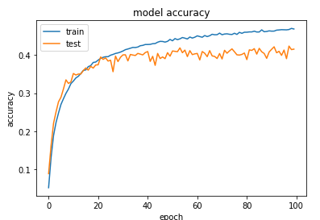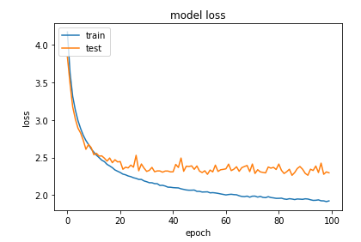

y_pred = model5.predict(X_test[[0]])

plt.imshow(X_test[0])

print('Dự đoán là hình: ', labels[np.argmax(y_pred)])

print('Thực tế là hình: ', labels[np.argmax(Y_test[0])])

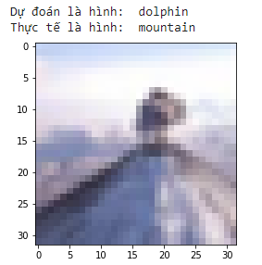

y_pred = model5.predict(X_test[[20]])

plt.imshow(X_test[20])

print('Dự đoán là hình: ', labels[np.argmax(y_pred)])

print('Thực tế là hình: ', labels[np.argmax(Y_test[20])])

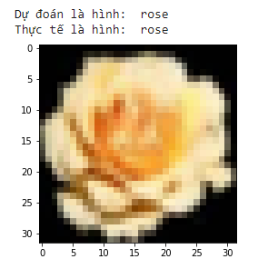

**Bài 2: Nhận diện khuôn mặt:**

import cv2

import os

import numpy as np

import matplotlib.pyplot as plt

from tensorflow.keras.utils import to_categorical

from sklearn.model_selection import train_test_split

from keras.models import Sequential

from keras.layers import Dense,Activation,Dropout

from keras.preprocessing.image import load_img

from google.colab import drive

drive.mount('/content/drive')

train_path = '/content/drive/MyDrive/nhan_dien_khuon_mat/train'

test_path = '/content/drive/MyDrive/nhan_dien_khuon_mat/test'

img = load_img('/content/drive/MyDrive/nhan_dien_khuon_mat/train/Hoa/Hoa (1).jpg')

rotated_image = img.rotate(-90)

plt.imshow(rotated_image)

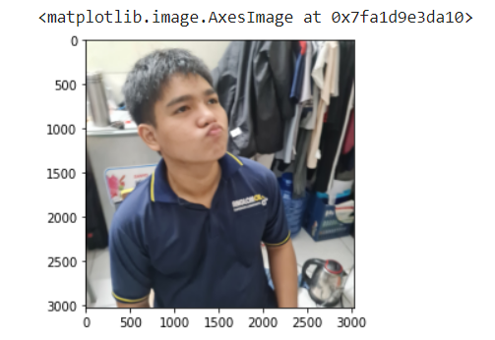

cv2.imread('/content/drive/MyDrive/nhan_dien_khuon_mat/train/Hoa/Hoa (1).jpg').shape

(3024, 3024, 3)

from tensorflow.keras.preprocessing.image import ImageDataGenerator

X_train = ImageDataGenerator(rescale=1/255)

X_test = ImageDataGenerator(rescale=1/255)

train_dataset = X_train.flow_from_directory(

    directory=r"/content/drive/MyDrive/nhan_dien_khuon_mat/train",

    target_size=(150, 150),

    batch_size=3,

    class_mode="categorical",

    )

test_dataset = X_test.flow_from_directory(

    directory=r"/content/drive/MyDrive/nhan_dien_khuon_mat/test",

    target_size=(150, 150),

    batch_size=3,

    class_mode= "categorical",

    )

Found 143 images belonging to 3 classes.

Found 53 images belonging to 3 classes.

train_dataset.class_indices

{'Hoa': 0, 'Huy': 1, 'Toan': 2}

from keras.layers.pooling import MaxPooling2D

from keras.backend import conv2d

from sklearn.model_selection import train_test_split

from keras.models import Sequential

from keras.layers import Conv2D,MaxPooling2D,Dropout

from keras.layers.core.flatten import Flatten

from keras.layers.core.flatten import Flatten

model = Sequential([

    Conv2D(16, 3, padding='same', activation='relu', input_shape=(150, 150, 3)),

    MaxPooling2D(),

    Dropout(0.2),

    Conv2D(32, 3, padding='same', activation='relu'),

    MaxPooling2D(),

    Conv2D(64, 3, padding='same', activation='relu'),

    MaxPooling2D(),

    Dropout(0.2),

    Conv2D(128, 3, padding='same', activation='relu'),

    MaxPooling2D(),

    Dropout(0.2),

    Conv2D(128, 3, padding='same', activation='relu'),

    MaxPooling2D(),

    Dropout(0.2),

    Flatten(),

    Dense(512, activation='relu'),

    Dense(3, activation='softmax')

])

model.summary()

from tensorflow.keras.optimizers import SGD

#opt = SGD(lr = 0.01, momentum= 0.9)

model.compile(optimizer='adam',loss ='categorical_crossentropy',metrics =['accuracy'])

history=model.fit(train_dataset,epochs=10,batch_size=64,verbose=1,validation_data= test_dataset)

import plotly.graph_objects as go

fig = go.Figure()

fig.add_trace(go.Scatter(x=history.epoch,

                         y=history.history['accuracy'],

                         mode='lines+markers',

                         name='Training accuracy'))

fig.add_trace(go.Scatter(x=history.epoch,

                         y=history.history['val_accuracy'],

                         mode='lines+markers',

                         name='Validation accuracy'))

fig.update_layout(title='Accuracy',

                  xaxis=dict(title='Epoch'),

                  yaxis=dict(title='Percentage'))

fig.show()

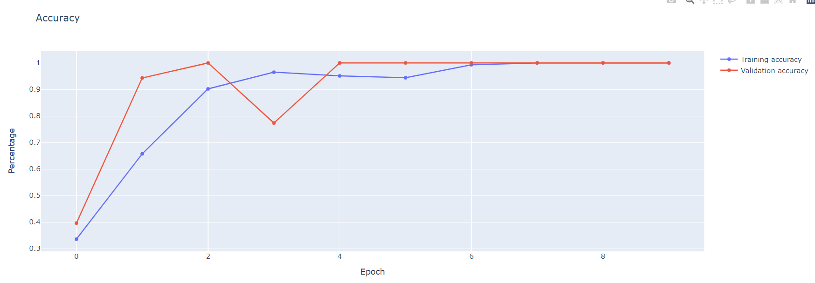

labels = {0: 'Hoa', 1: 'Huy', 2: 'Toan'}

from keras.preprocessing.image import load_img, img_to_array

img = load_img('/content/Hoa_2.jpg', target_size =(150,150))

rotated_image = img.rotate(-90)

plt.imshow(rotated_image)

img = img_to_array(img)

img = img.reshape(1,150,150,3)

img = img.astype('float32')

img = img/255

img.shape

val = model5.predict(img)

np.argmax(val,axis= 1)

print('Main ba: ', labels[np.argmax(val)])

img = load_img('/content/Huy_19146060.jpg', target_size =(150,150))

plt.imshow(img)

img = img_to_array(img)

img = img.reshape(1,150,150,3)

img = img.astype('float32')

img = img/255

img.shape

val = model5.predict(img)

np.argmax(val,axis= 1)

print('Main ba: ', labels[np.argmax(val)])

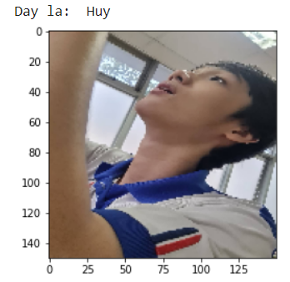

img = load_img('/content/drive/MyDrive/nhan_dien_khuon_mat/train/Toan/Toan (30).JPG', target_size =(150,150))

rotated_image = img.rotate(-90)

plt.imshow(rotated_image)

img = img_to_array(img)

img = img.reshape(1,150,150,3)

img = img.astype('float32')

img = img/255

img.shape

val = model5.predict(img)

np.argmax(val,axis= 1)

print('Day la ', labels[np.argmax(val)])

**Bài 3: Nhận diện 10 món ăn VN**

import cv2

import os

import numpy as np

import matplotlib.pyplot as plt

from tensorflow.keras.utils import to_categorical

from sklearn.model_selection import train_test_split

from keras.models import Sequential

from keras.layers import Dense,Activation,Dropout

from keras.preprocessing.image import load_img

from google.colab import drive

drive.mount('/content/drive')

train_path = '/content/drive/MyDrive/VN_food/train'

test_path = '/content/drive/MyDrive/VN_food/test'

img = load_img('/content/drive/MyDrive/VN_food/train/banhchung/banhchung (1).jpg')

rotated_image = img.rotate(0)

plt.imshow(rotated_image)

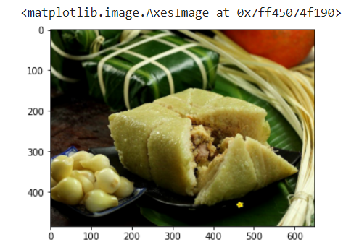

from tensorflow.keras.preprocessing.image import ImageDataGenerator

X_train = ImageDataGenerator(rescale=1/255)

X_test = ImageDataGenerator(rescale=1/255)

train_dataset = X_train.flow_from_directory(

    directory=r"/content/drive/MyDrive/VN_food/train",

    target_size=(150, 150),

    batch_size=3,

    class_mode="categorical",

    )

test_dataset = X_test.flow_from_directory(

    directory=r"/content/drive/MyDrive/VN_food/test",

    target_size=(150, 150),

    batch_size=3,

    class_mode= "categorical",

    )

Found 433 images belonging to 10 classes.

Found 159 images belonging to 10 classes.

train_dataset.class_indices

{'banhchung': 0,

'banhcuon': 1,

'banhmi': 2,

'banhxeo': 3,

'bunbo': 4,

'buncha': 5,

'bundaumamtom': 6,

'chagio': 7,

'comtam': 8,

'goicuon': 9}

from keras.layers.pooling import MaxPooling2D

from keras.backend import conv2d

from sklearn.model_selection import train_test_split

from keras.models import Sequential

from keras.layers import Conv2D,MaxPooling2D,Dropout

from keras.layers.core.flatten import Flatten

from keras.layers.core.flatten import Flatten

model = Sequential([

    Conv2D(16,3, padding='same', activation='relu', input_shape=(150, 150, 3)),

    MaxPooling2D(),

    Dropout(0.2),

    Conv2D(32, 3, padding='same', activation='relu'),

    MaxPooling2D(),

    Conv2D(64, 3, padding='same', activation='relu'),

    MaxPooling2D(),

    Dropout(0.2),

    Conv2D(128, 3, padding='same', activation='relu'),

    MaxPooling2D(),

    Dropout(0.2),

    Conv2D(128, 3, padding='same', activation='relu'),

    MaxPooling2D(),

    Dropout(0.2),

    Flatten(),

    Dense(512, activation='relu'),

    Dense(10, activation='softmax')

])

model.summary()

model.compile(optimizer='adam',loss ='categorical_crossentropy',metrics =['accuracy'])

history=model.fit(train_dataset,epochs=30,batch_size=64,verbose=1,validation_data= test_dataset)

import plotly.graph_objects as go

fig = go.Figure()

model.save('vn_food_training.h5')

from keras.models import load_model

model5 = load_model('vn_food_training.h5')

fig.add_trace(go.Scatter(x=history.epoch,

                         y=history.history['accuracy'],

                         mode='lines+markers',

                         name='Training accuracy'))

fig.add_trace(go.Scatter(x=history.epoch,

                         y=history.history['val_accuracy'],

                         mode='lines+markers',

                         name='Validation accuracy'))

fig.update_layout(title='Accuracy',

                  xaxis=dict(title='Epoch'),

                  yaxis=dict(title='Percentage'))

fig.show()

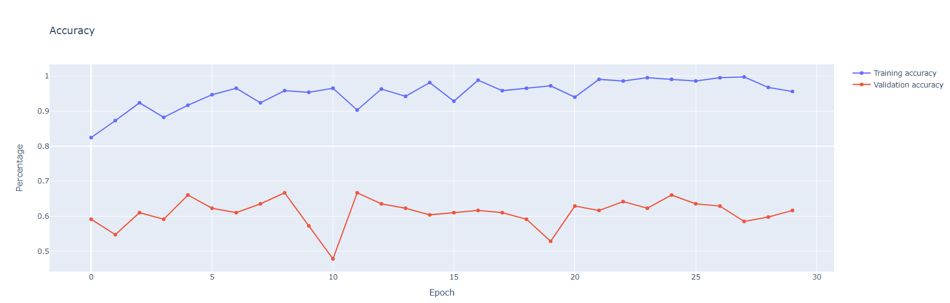

labels = {0: 'banhchung',

          1: 'banhcuon',

          2:'banhmi',

          3:'banhxeo',

          4:'bunbo',

          5:'buncha',

          6:'bundaumamtom',

          7:'chagio',

          8:'comtam',

          9:'goicuon'}

from keras.preprocessing.image import load_img, img_to_array

img = load_img('/content/banhmi (33).jpg', target_size =(150,150))

plt.imshow(img)

img = img_to_array(img)

img = img.reshape(1,150,150,3)

img = img.astype('float32')

img = img/255

img.shape

val = model5.predict(img)

np.argmax(val,axis= 1)

print('Day la mon: ', labels[np.argmax(val)])

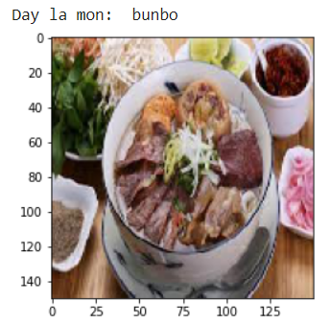

**Bài 4: Nhận diện 10 loại trái cây nhiệt đới**

import cv2

import os

import numpy as np

import matplotlib.pyplot as plt

from keras.models import Sequential

from keras.layers import Dense,Activation,Dropout

from keras.preprocessing.image import load_img

from tensorflow.keras.preprocessing.image import ImageDataGenerator

from keras.layers.pooling import MaxPooling2D

from keras.backend import conv2d

from sklearn.model_selection import train_test_split

from keras.models import Sequential

from keras.layers import Conv2D,MaxPooling2D,Dropout

from keras.layers.core.flatten import Flatten

from google.colab import drive

drive.mount('/content/drive')

train_path = '/content/drive/MyDrive/Tropical_fruit/train'

test_path = '/content/drive/MyDrive/Tropical_fruit/test'

img = load_img('/content/drive/MyDrive/Tropical_fruit/train/mango/xoai (1).jpg')

rotated_image = img.rotate(0)

plt.imshow(rotated_image)

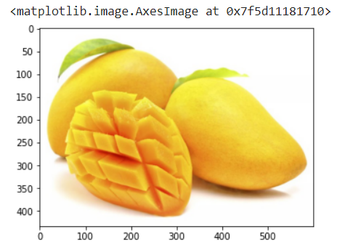

X_train = ImageDataGenerator(rescale=1/255)

X_test = ImageDataGenerator(rescale=1/255)

train_dataset = X_train.flow_from_directory(

    directory=r"/content/drive/MyDrive/Tropical_fruit/train",

    target_size=(150, 150),

    batch_size=3,

    class_mode="categorical",

    )

test_dataset = X_test.flow_from_directory(

    directory=r"/content/drive/MyDrive/Tropical_fruit/test",

    target_size=(150, 150),

    batch_size=3,

    class_mode= "categorical",

    )

Found 454 images belonging to 10 classes.

Found 193 images belonging to 10 classes.

train_dataset.class_indices

{'apple': 0,

'avovado': 1,

'banana': 2,

'dragonfruit': 3,

'kiwi': 4,

'mango': 5,

'orange': 6,

'passionfruit': 7,

'pinaple': 8,

'watermelon': 9}

from keras.layers.core.flatten import Flatten

model = Sequential([

    Conv2D(16,(3,3), padding='same', activation='relu', input_shape=(150, 150, 3)),

    MaxPooling2D(),

    Dropout(0.2),

    Conv2D(32,(3,3), padding='same', activation='relu'),

    MaxPooling2D(),

    Conv2D(64,(3,3), padding='same', activation='relu'),

    MaxPooling2D(),

    Dropout(0.2),

    Conv2D(128,(3,3), padding='same', activation='relu'),

    MaxPooling2D(),

    Dropout(0.2),

    Conv2D(128,(3,3), padding='same', activation='relu'),

    MaxPooling2D(),

    Dropout(0.2),

    Flatten(),

    Dense(512, activation='relu'),

    Dense(10, activation='softmax')

])

model.compile(optimizer='adam',loss ='categorical_crossentropy',metrics =['accuracy'])

history=model.fit(train_dataset,epochs=30,batch_size=64,verbose=1,validation_data= test_dataset)

model.save('10_Tropical_fruit_training.h5')

from keras.models import load_model

model5 = load_model('10_Tropical_fruit_training.h5')

import plotly.graph_objects as go

fig = go.Figure()

fig.add_trace(go.Scatter(x=history.epoch,

                         y=history.history['accuracy'],

                         mode='lines+markers',

                         name='Training accuracy'))

fig.add_trace(go.Scatter(x=history.epoch,

                         y=history.history['val_accuracy'],

                         mode='lines+markers',

                         name='Validation accuracy'))

fig.update_layout(title='Accuracy',

                  xaxis=dict(title='Epoch'),

                  yaxis=dict(title='Percentage'))

fig.show()

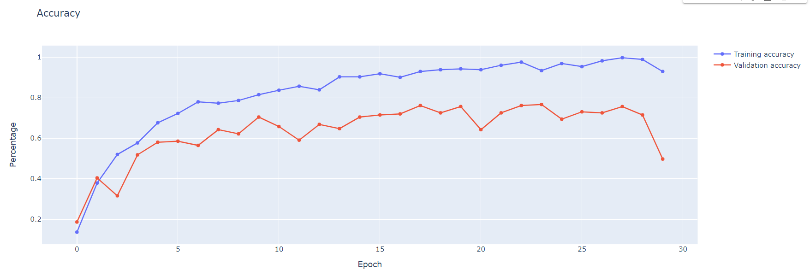

labels = {0: 'apple',

          1: 'avovado',

          2: 'banana',

          3: 'dragonfruit',

          4: 'kiwi',

          5: 'mango',

          6: 'orange',

          7: 'passionfruit',

          8: 'pinaple',

          9: 'watermelon'}

from keras.preprocessing.image import load_img, img_to_array

img = load_img('/content/drive/MyDrive/Tropical_fruit/train/ ', target_size =(150,150))

plt.imshow(img)

img = img_to_array(img)

img = img.reshape(1,150,150,3)

img = img.astype('float32')

img = img/255

img.shape

val = model5.predict(img)

np.argmax(val,axis= 1)

print('Day la trai: ', labels[np.argmax(val)])

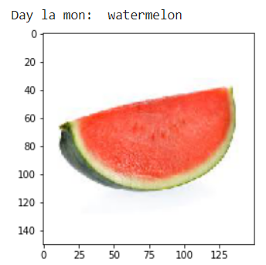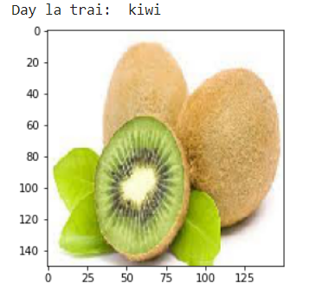

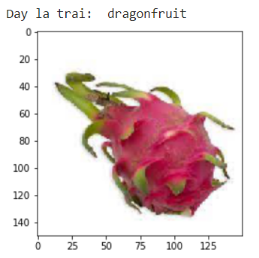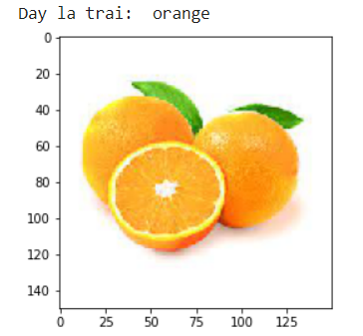

**Bài 5: Nhận diện tiền VN**

import cv2

import os

import numpy as np

import matplotlib.pyplot as plt

from keras.models import Sequential

from keras.layers import Dense,Activation,Dropout

from keras.preprocessing.image import load_img

from tensorflow.keras.preprocessing.image import ImageDataGenerator

from keras.layers.pooling import MaxPooling2D

from keras.backend import conv2d

from sklearn.model_selection import train_test_split

from keras.models import Sequential

from keras.layers import Conv2D,MaxPooling2D,Dropout

from keras.layers.core.flatten import Flatten

from google.colab import drive

drive.mount('/content/drive')

train_path = '/content/drive/MyDrive/Nhan_dien_tien/train'

test_path = '/content/drive/MyDrive/Nhan_dien_tien/test'

img = load_img('/content/drive/MyDrive/Nhan_dien_tien/train/1k/1k (14).jpg')

rotated_image = img.rotate(0)

plt.imshow(rotated_image)

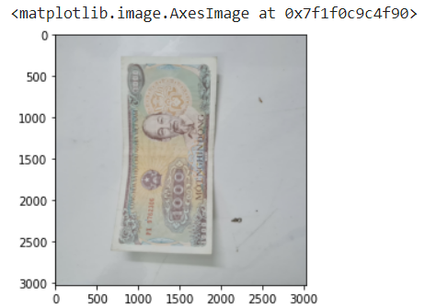

X_train = ImageDataGenerator(rescale=1/255)

X_test = ImageDataGenerator(rescale=1/255)

train_dataset = X_train.flow_from_directory(

    directory=r"/content/drive/MyDrive/Nhan_dien_tien/train",

    target_size=(150, 150),

    batch_size=3,

    class_mode="categorical",

    )

test_dataset = X_test.flow_from_directory(

    directory=r"/content/drive/MyDrive/Nhan_dien_tien/test",

    target_size=(150, 150),

    batch_size=3,

    class_mode= "categorical",

    )

Found 452 images belonging to 9 classes.

Found 238 images belonging to 9 classes.

train_dataset.class_indices

{'100k': 0,

'10k': 1,

'1k': 2,

'200k': 3,

'20k': 4,

'2k': 5,

'500k': 6,

'50k': 7,

'5k': 8}

from keras.layers.core.flatten import Flatten

model = Sequential([

    Conv2D(16,(3,3), padding='same', activation='relu', input_shape=(150, 150, 3)),

    MaxPooling2D(),

    Dropout(0.2),

    Conv2D(32,(3,3), padding='same', activation='relu'),

    MaxPooling2D(),

    Conv2D(64,(3,3), padding='same', activation='relu'),

    MaxPooling2D(),

    Dropout(0.2),

    Conv2D(128,(3,3), padding='same', activation='relu'),

    MaxPooling2D(),

    Dropout(0.2),

    Conv2D(128,(3,3), padding='same', activation='relu'),

    MaxPooling2D(),

    Dropout(0.2),

    Flatten(),

    Dense(512, activation='relu'),

    Dense(9, activation='softmax')

])

model.compile(optimizer='adam',loss ='categorical_crossentropy',metrics =['accuracy'])

history=model.fit(train_dataset,epochs=30,batch_size=64,verbose=1,validation_data= test_dataset)

model.save('money_training.h5')

from keras.models import load_model

model5 = load_model('money_training.h5')

import plotly.graph_objects as go

fig = go.Figure()

fig.add_trace(go.Scatter(x=history.epoch,

                         y=history.history['accuracy'],

                         mode='lines+markers',

                         name='Training accuracy'))

fig.add_trace(go.Scatter(x=history.epoch,

                         y=history.history['val_accuracy'],

                         mode='lines+markers',

                         name='Validation accuracy'))

fig.update_layout(title='Accuracy',

                  xaxis=dict(title='Epoch'),

                  yaxis=dict(title='Percentage'))

fig.show()

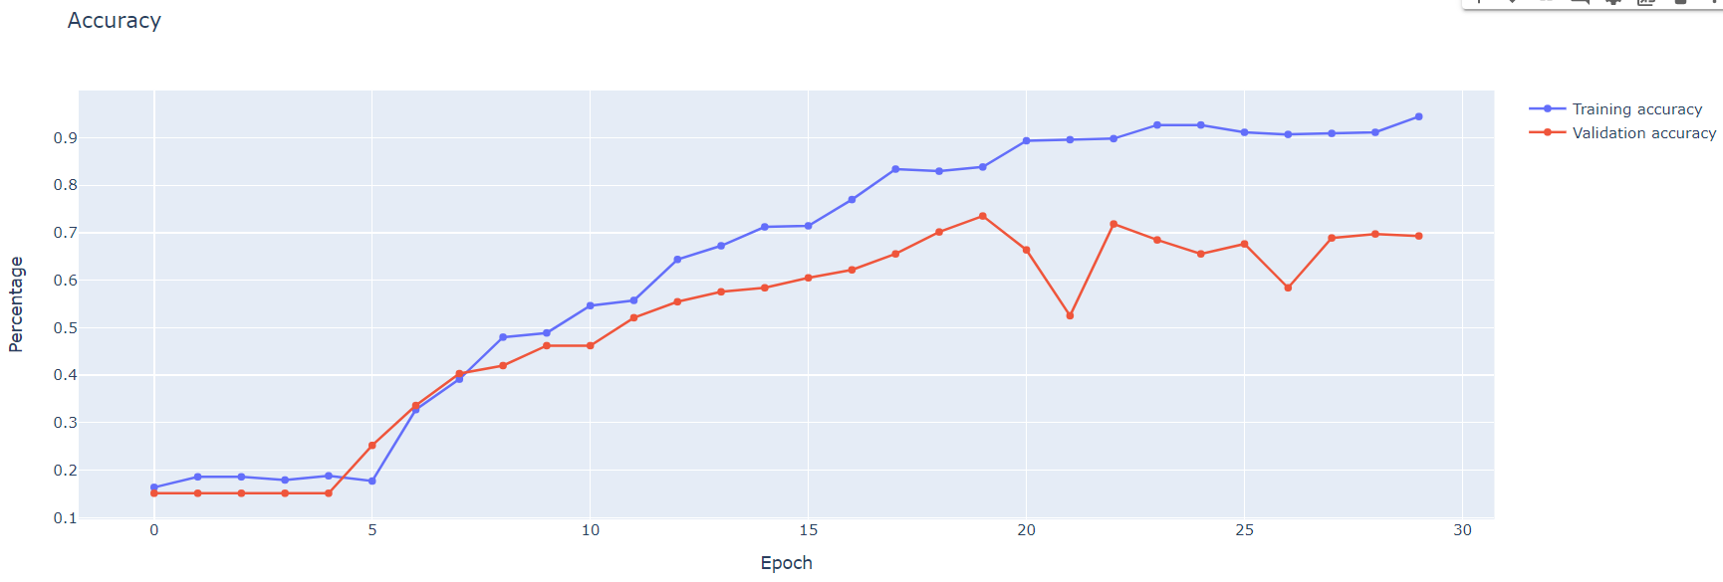

labels = {0: '100k',

          1: '10k',

          2: '1k',

          3: '200k',

          4: '20k',

          5: '2k',

          6: '500k',

          7: '50k',

          8: '5k'}

from keras.preprocessing.image import load_img, img_to_array

img = load_img('/content/drive/MyDrive/Nhan_dien_tien/test/.jpg', target_size =(150,150))

plt.imshow(img)

img = img_to_array(img)

img = img.reshape(1,150,150,3)

img = img.astype('float32')

img = img/255

img.shape

val = model5.predict(img)

np.argmax(val,axis= 1)

print('Day la to tien: ', labels[np.argmax(val)])

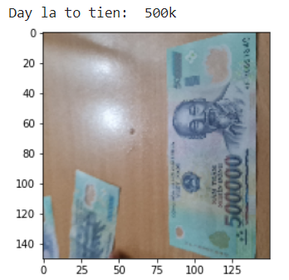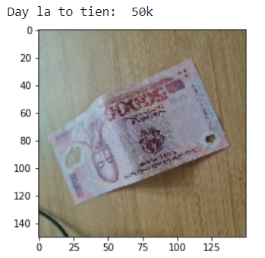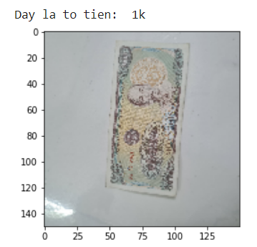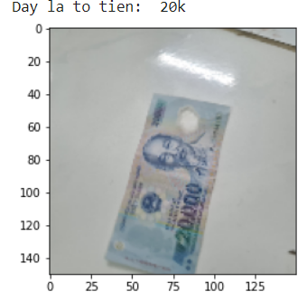

**Bài 6: Nhận diện chỉ tay**

import cv2

import os

import numpy as np

import matplotlib.pyplot as plt

from keras.models import Sequential

from keras.layers import Dense,Activation,Dropout

from keras.preprocessing.image import load_img

from tensorflow.keras.preprocessing.image import ImageDataGenerator

from keras.layers.pooling import MaxPooling2D

from keras.backend import conv2d

from sklearn.model_selection import train_test_split

from keras.models import Sequential

from keras.layers import Conv2D,MaxPooling2D,Dropout

from keras.layers.core.flatten import Flatten

from google.colab import drive

drive.mount('/content/drive')

train_path = '/content/drive/MyDrive/Nhan_dien_van_tay/train'

test_path = '/content/drive/MyDrive/Nhan_dien_van_tay/test'

img = load_img('/content/drive/MyDrive/Nhan_dan_chi_tay/train/giauco/3 (10).jpg')

rotated_image = img.rotate(0)

plt.imshow(rotated_image)

X_train = ImageDataGenerator(rescale=1/255)

X_test = ImageDataGenerator(rescale=1/255)

train_dataset = X_train.flow_from_directory(

    directory=r"/content/drive/MyDrive/Nhan_dan_chi_tay/train",

    target_size=(150, 150),

    batch_size=3,

    class_mode="categorical",

    )

test_dataset = X_test.flow_from_directory(

    directory=r"/content/drive/MyDrive/Nhan_dan_chi_tay/test",

    target_size=(150, 150),

    batch_size=3,

    class_mode= "categorical",

    )

Found 100 images belonging to 4 classes.

Found 44 images belonging to 4 classes.

train_dataset.class_indices

{'co_tinh_cam_va_cong_viec_suat_sac': 0,

'duong_tinh_duyen_trac_tro': 1,

'giauco': 2,

'tainang_thongminh': 3}

from keras.layers.core.flatten import Flatten

model = Sequential([

    Conv2D(16,(3,3), padding='same', activation='relu', input_shape=(150, 150, 3)),

    MaxPooling2D(),

    Dropout(0.2),

    Conv2D(32,(3,3), padding='same', activation='relu'),

    MaxPooling2D(),

    Conv2D(64,(3,3), padding='same', activation='relu'),

    MaxPooling2D(),

    Dropout(0.2),

    Conv2D(128,(3,3), padding='same', activation='relu'),

    MaxPooling2D(),

    Dropout(0.2),

    Conv2D(128,(3,3), padding='same', activation='relu'),

    MaxPooling2D(),

    Dropout(0.2),

    Flatten(),

    Dense(512, activation='relu'),

    Dense(4, activation='softmax')

])

model.compile(optimizer='adam',loss ='categorical_crossentropy',metrics =['accuracy'])

history=model.fit(train_dataset,epochs=30,batch_size=64,verbose=1,validation_data= test_dataset)

model.save('palm_reading.h5')

from keras.models import load_model

model5 = load_model('palm_reading.h5')

import plotly.graph_objects as go

fig = go.Figure()

fig.add_trace(go.Scatter(x=history.epoch,

                         y=history.history['accuracy'],

                         mode='lines+markers',

                         name='Training accuracy'))

fig.add_trace(go.Scatter(x=history.epoch,

                         y=history.history['val_accuracy'],

                         mode='lines+markers',

                         name='Validation accuracy'))

fig.update_layout(title='Accuracy',

                  xaxis=dict(title='Epoch'),

                  yaxis=dict(title='Percentage'))

fig.show()

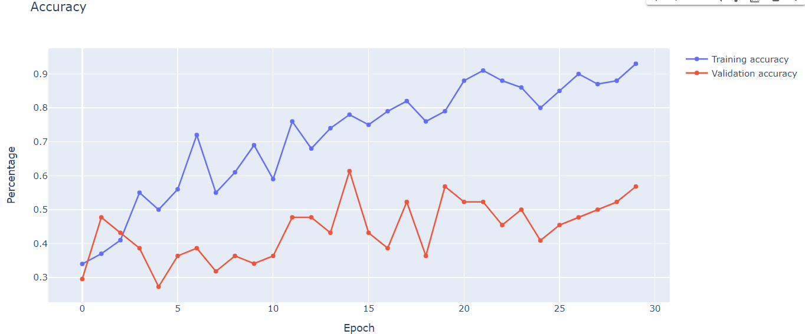

labels = {0: 'co_tinh_cam_va_cong_viec_suat_sac',

          1: 'duong_tinh_duyen_trac_tro',

          2: 'giauco',

          3: 'tainang_thongminh'}

from keras.preprocessing.image import load_img, img_to_array

img = load_img('/content/tay_Huy.jpg', target_size =(150,150))

plt.imshow(img)

img = img_to_array(img)

img = img.reshape(1,150,150,3)

img = img.astype('float32')

img = img/255

img.shape

val = model5.predict(img)

np.argmax(val,axis= 1)

print('Du doan ban se co: ', labels[np.argmax(val)])

Huy hand predict:

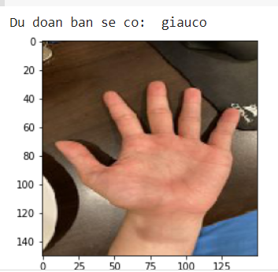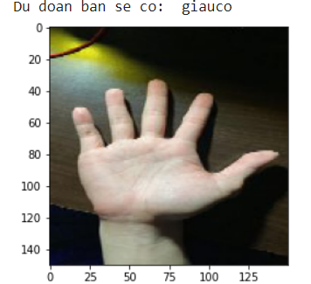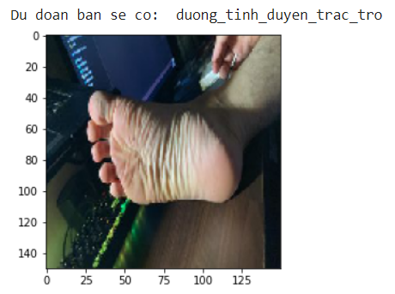

Hoa hand predict:

